

LAB REPORT

| 01 |
| --- |

CSE416: Web Engineering Lab

Submitted To

Md. Ashraful Islam Talukder

Lecturer

Department of CSE

Daffodil International University

Submitted By

Student ID: 221-15-4869

Student Name: Pritom Saha

Section: 61_E1

Department of CSE

Daffodil International University

Date of Assignment Distribution: 18-06-2025

Date of Assignment Submission: 18-06-2025

| Experiment No: 01 | Experiment Name: Design and implement a static web page using HTML and CSS |
| --- | --- |

Obtained Output:

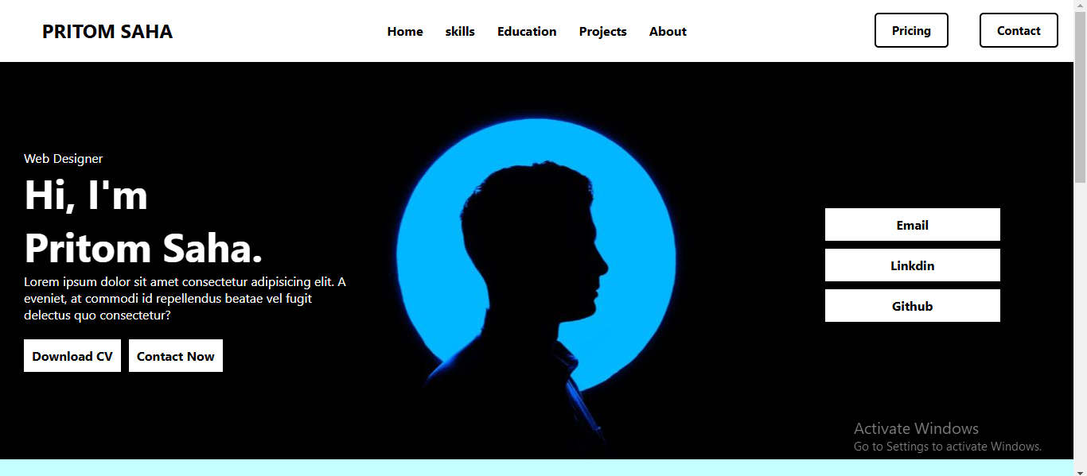

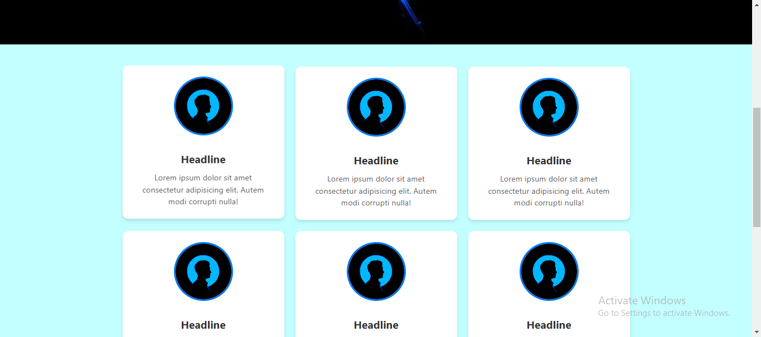

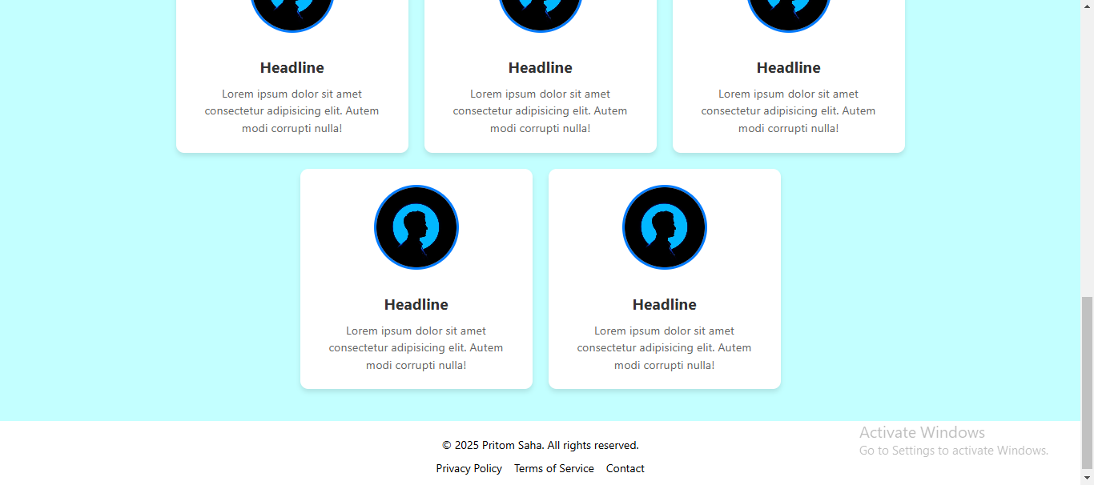

**Code:**

**HTML**

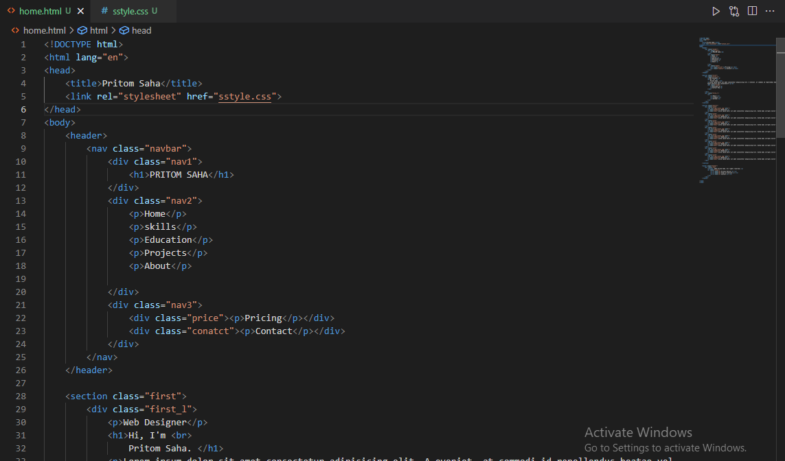

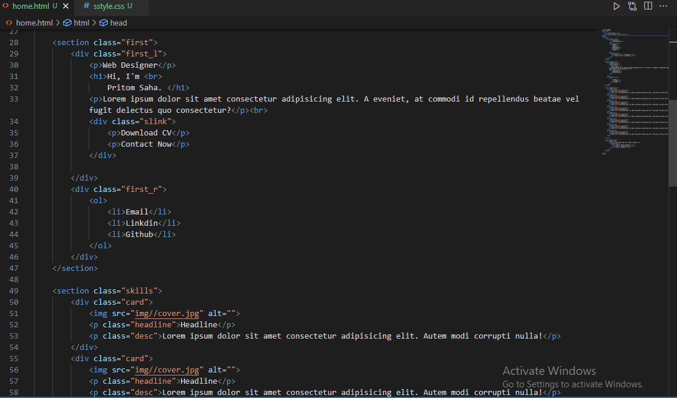

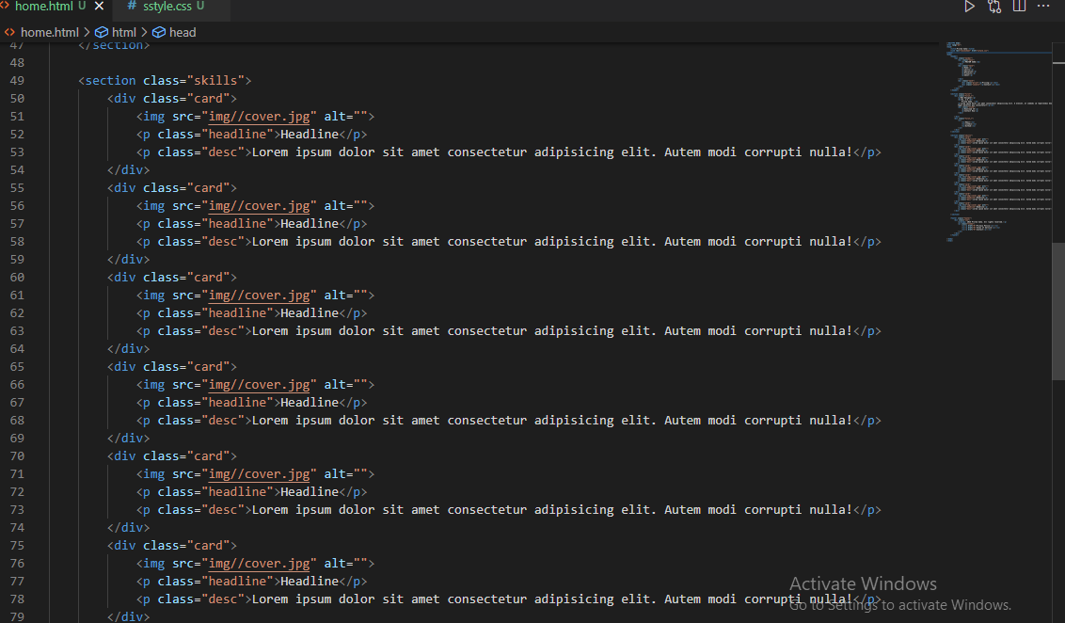

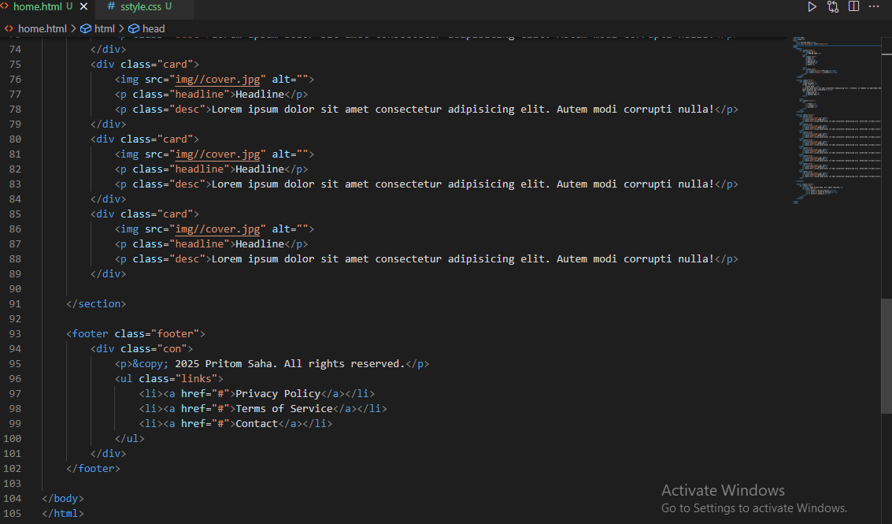

**CSS**

